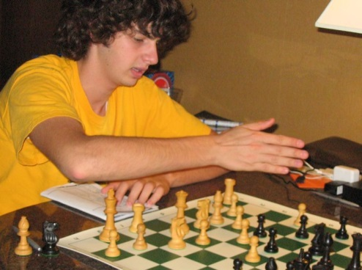

Karen Chernesky Fotis: You?ve been playing chess for a long time.  Why do you still play?

BB: Chess is a game that is so beautiful I do not think I could ever get bored of it. Also, traveling to play chess is lots of fun. Some of my favorite times of the year are when our chess team goes to play at nationals. Chess is also a great way to meet people, for example I met one of my best friends at a chess tournament in Milwaukee.

KC:  Is it true that pattern recognition is a big part of chess?  How important is it to your game?

BB: I have no clue which side uses pattern recognition but it is very important in chess. You study tactics so when you are playing you can see the same sort of patterns you see in puzzles. Pattern recognition is very important in my game, since I am a very aggressive, tactical player.

KC:  Do you have a training strategy that gets you ready for a tournament?  How about a strategy you use to get you ready for the next game?

BB: To get ready for a tournament I try to play as much as possible before the tournament and also study. For studying, I normally look at 4 to 5 Tal games and 2 Fischer games. During the tournament the only way to get ready for the next game is just look over the last game if it is worth it. But, normally I do not look over my games during the tournament unless there is a long break between rounds. The only way to get me fired up for a round is if I am playing against a higher rated player or if it is the first round of a tournament.

KC:  Do you have a favorite album or artist you listen to fire you up?

BB:  To get pumped up before a game I normally listen to ?Rage Against the Machine.?

KC:  How do you keep your focus during a long game?  Is it true that a ?won game? is the hardest to win?

BB: One of my favorite things about chess is the complete silence in the tournament room. It is a very calming environment for me in which I find it easy to focus. I have never really had a problem staying focused to my game. I don?t think a won game is the hardest one to win just because if you are good enough to be winning you should be good enough to finish your opponent off.

KC:  Do you ever get the feeling that crowds of people suddenly appear to watch as you lose a game?

BB: Yeah, that whole crowd thing. The crowds don?t really do anything to me normally if I am winning or if I?m losing. When I was younger the crowds used to scare me and make me so nervous even when I was winning. Now I just try to think they are not there and that I am probably making better moves then half of the people watching so I don?t really care.

KC:  How about a little personal information- Do you have a favorite move, book, class, TV show?

BB:  A little personal info? How about I like long walks on the beach followed by a candle light dinner. OK. For real, my favorite movie has to be ?The Sandlot.? Since I love baseball as much as chess, this has to be a baseball player?s favorite. My favorite book is ?The Grapes of Wrath? by John Steinbeck. This book has an amazing person in it, Tom Joad, who I wish I could be like.   AP Chemistry is my favorite class by far this year, since it has one of the coolest teachers of all time. Really, he is.  If you ever want to see the real life Professor Dumbledore, visit him. I do not watch too much TV anymore.  There are so many other things better to do with your time than sitting and being lazy. But, if I am watching TV (and being lazy) I am most likely watching something on ESPN like Baseball Tonight, or my other station is the History Channel where I just watch to learn (so, not being as lazy).